The week in 7 charts

12th of October 2026

----------------------------------------------------------------------------------------------

Chart #1: This bull market is nearly four years old

Over the past 50 years, five other bull markets have reached this age, and each of them went on to last at least one more year.

In fact, a bull market lasting several more years is entirely plausible.

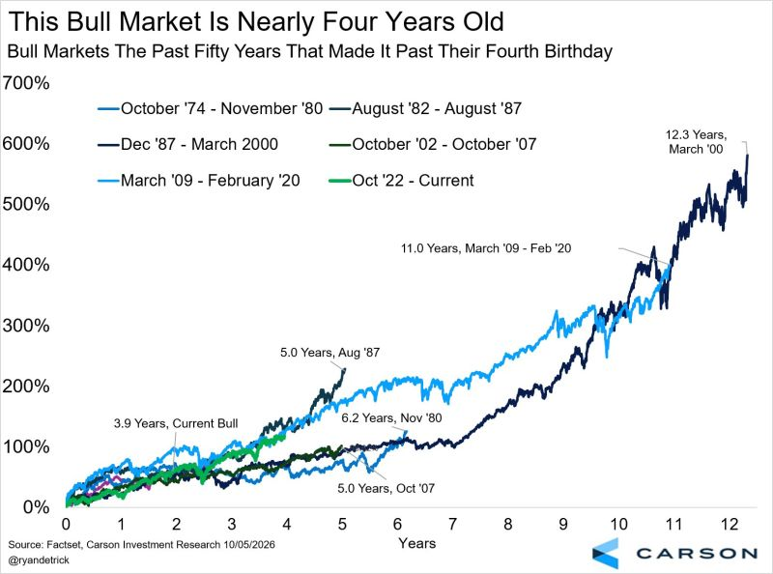

Source: Ryan Detrick

Chart #2: Profits are powering the S&P 500 bull market

The S&P 500 has gained 168% since 2019.

Earnings growth accounts for 137% of that return and dividends for 26%.

Multiple expansion has contributed almost nothing (just 5%).

The market is often described as overvalued, yet this breakdown suggests otherwise.

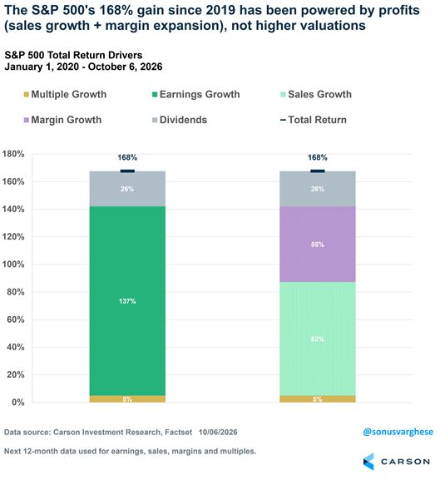

Source: Ryan Detrick

Chart #3: More than 50% of Harvard’s stock portfolio is invested into SpaceX

Here is the composition of Harvard’s endowment equity portfolio at the end of the second quarter of 2026.

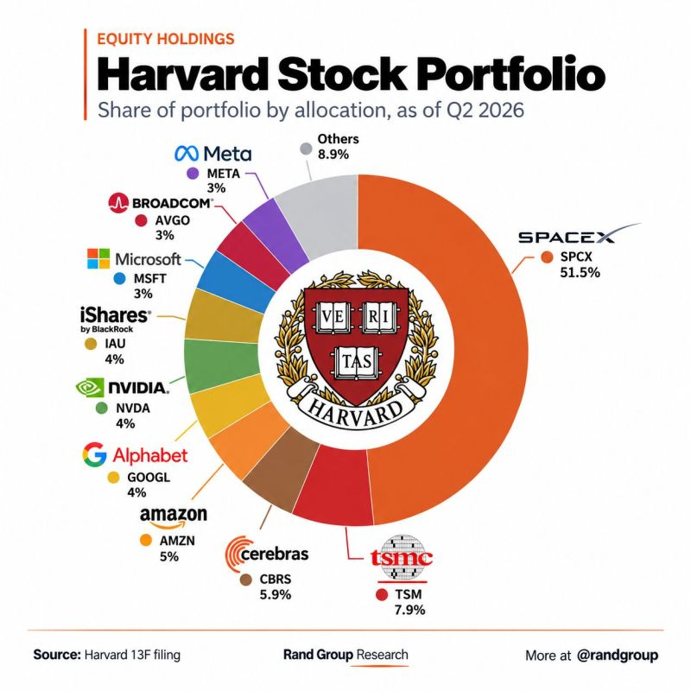

Source: Rand Group

Chart #4: French companies now borrow CHEAPER than the French state

€215bn of French corporate bonds now trade at tighter spreads than government bonds, 18 times the amount in January.

This means 38% of the investment-grade market now treats the government, rather than companies, as the greater credit risk.

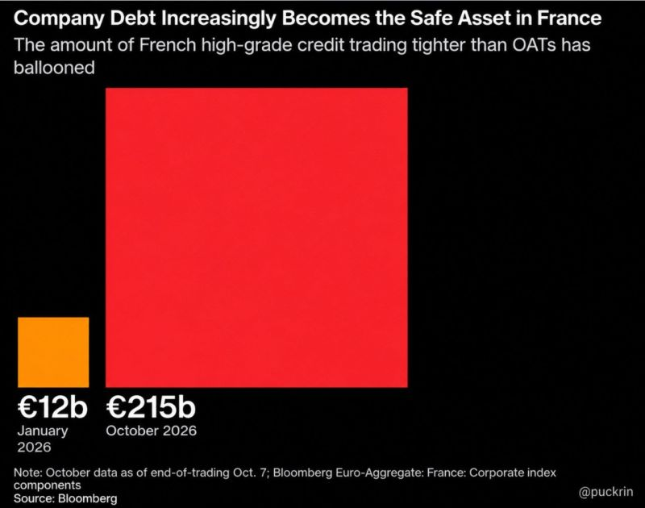

Source: Nic @puckrin
Bloomberg

Chart #5: Europe’s LNG supply is becoming overwhelmingly American

The United States’ share of EU LNG imports has risen from 28% in early 2021 to 63.2% today, and IEEFA expects it could reach 80% by 2028.

Two shocks sped up this shift: Europe’s exit from Russian LNG and disruptions to supply from Qatar.

US cargoes provide flexibility, but they go to the highest bidder. When Asian buyers offer more, Europe has to compete or pay a higher price.

Europe has broken free of one energy dependence. Is it now creating another? With US LNG covering almost two-thirds of imports, does it strengthen Europe’s energy security or become its next point of vulnerability?

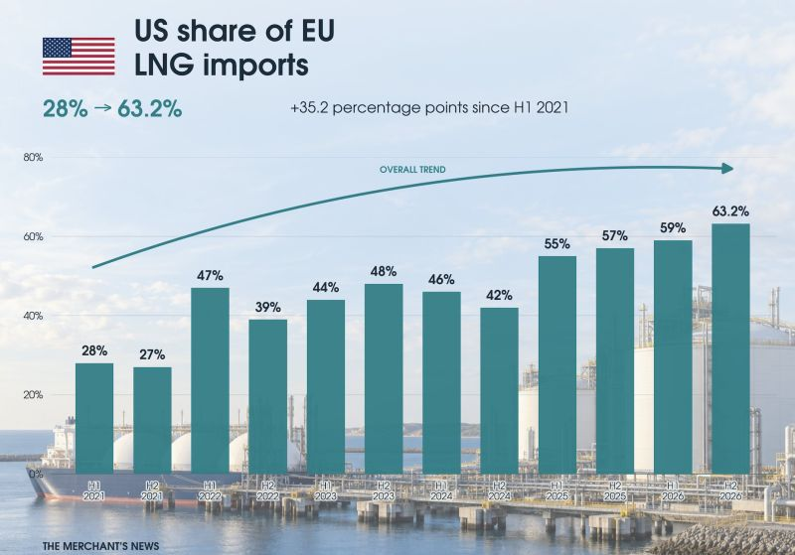

Source : Jack Prandelli on X

Chart #6: Europe has world-class talent. Can it build more world-class companies?

The size of America’s technology leaders raises a wider question: why does Europe find it so hard to turn scientific excellence into companies of similar scale?

Europe has no shortage of exceptional engineers, researchers and entrepreneurs.

However, fragmented markets, complex regulation, slow permitting and limited access to growth capital can make it harder for companies to scale.

Robust consumer protection and fair taxation pursue legitimate aims. The task is to balance them with incentives to invest, innovate and take risks.

Artificial intelligence makes this task more pressing.

Europe has the talent to play a part in shaping this revolution. Converting that potential into economic leadership will require a business environment in which ambitious companies can expand across borders.

The opportunity is clear: make it easier for European innovations to become global successes.

What should Europe reform first?

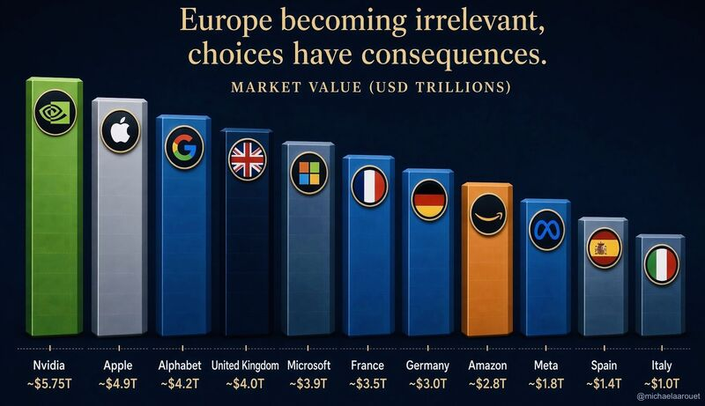

Source : Michel A.Arouet

Chart #7: South America’s political shift now puts Brazil in the spotlight

🇧🇷 The political realignment across South America is now turning attention to Brazil.

At the end of 2023, seven of the region’s 12 governments leaned to the left. Seven are now led by right-wing or centre-right leaders.

Brazil’s runoff on 25 October could take this shift further.

Flávio Bolsonaro finished ahead of Lula in the first round, with 47% against 44.9%.

For investors, the implications extend well beyond politics.

🛢️ Brazil is South America’s largest oil producer, and its output hit a record 4.62 million barrels per day in August.

Petrobras is central to this energy story. Its ADRs rose by around 10% on the morning after the first round.

The next president could influence the company’s fuel pricing, dividend policy and investment priorities.

In effect, Brazil’s election is also a vote on the future of its energy champion.

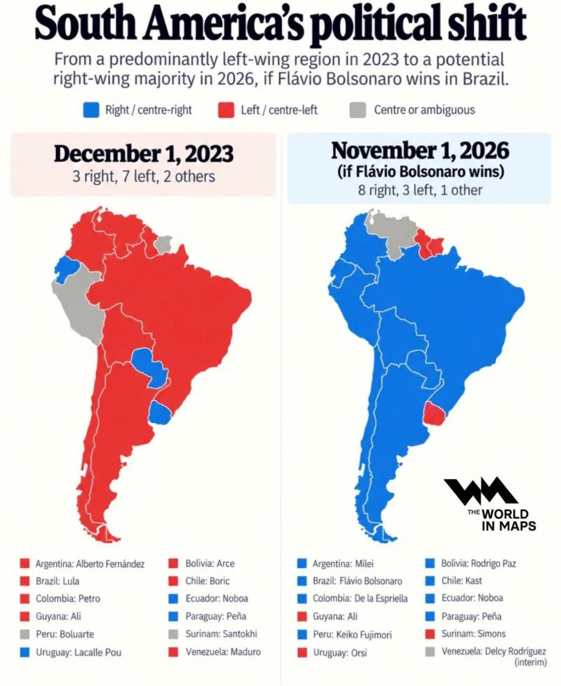

Source: Jack Prandelli on X, The World in Maps

